Title

Contents

User Interface Design 3

## User Interface Design

Local database selection window

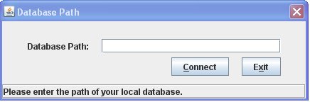

Networked database selection Window

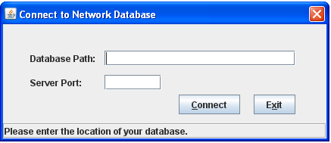

Server Window

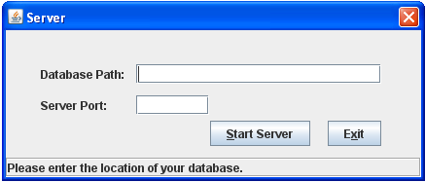

Main Window

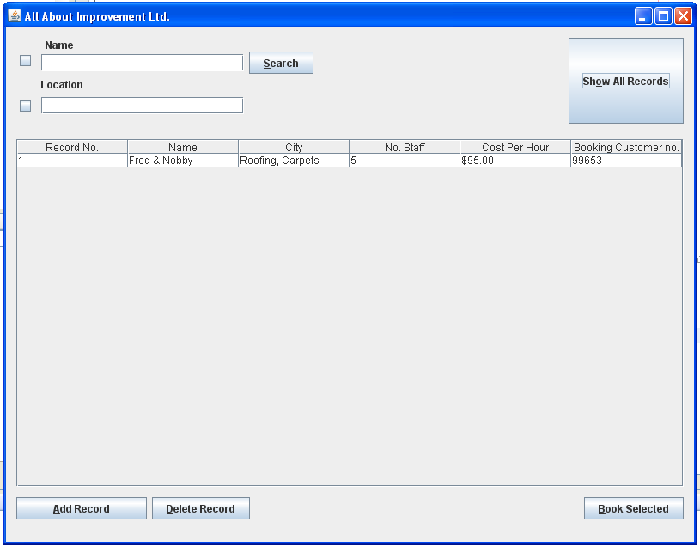

Test Location

H:\\SJDwork\\MF_SJD\\db-2x2_WORKING.db